DE-AT-PL-4M MC Project (Interim Coupling)
Published in March 2020
Purpose of this document
This document summarizes the most important information on the Interim Coupling for market participants.
What is the main purpose of the project?
The aim of the Interim Coupling Project is to implement NTC-based day-ahead market coupling of the MRC area and 4MMC area via the respective Bidding Zone Borders: DE-CZ, DE-PL, PL-CZ, PL-SK, CZ-AT, AT-HU, and thereby creating the European Single Day-Ahead Market (SDAC). By the introduction of implicit allocation on the abovementioned Bidding Zone Borders, the two regions MRC and 4MMC merging into SDAC will be applying a single day-ahead allocation process.

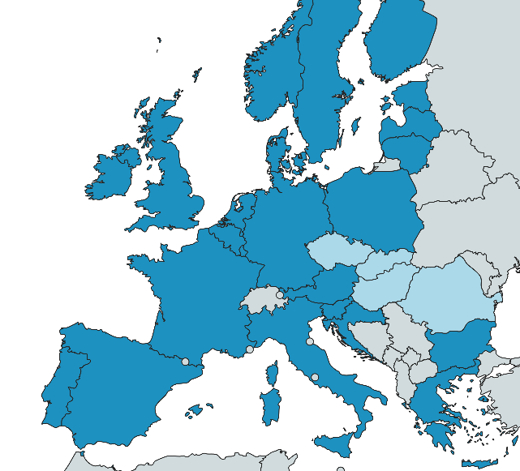
Picture 1: SDAC - dark blue: MRC region; light blue: 4MMC region
The project is to be understood as an interim step towards the implementation of Flow-Based Market Coupling (FBMC) in the Core region. The NTC-based capacity calculation and allocation on the abovementioned borders will be replaced by Core flow-based capacity calculation and allocation once Core FBMC is implemented.
What are the main changes that this project will bring for the market participants?
The main implications for the market participants are the following:
- The day-ahead market gate closure time (GCT) for all bidding areas will be unified to 12:00h throughout the whole SDAC area. Thus, the market participants from CZ, SK, HU and RO bidding areas, will have an opportunity to prolong their bidding activities for an hour. The exact timings for market results publication will be adjusted accordingly and communicated in due time prior to the go-live.
- The SDAC area including the former MRC and 4MMC regions should, due to the larger-scale, bring more trading opportunities on the day-ahead market.
- Daily explicit auctions conducted via JAO on DE-CZ, DE-PL, PL-CZ, PL-SK, CZ-AT and AT-HU Bidding Zone Borders will be ceased and replaced by implicit allocation of cross-border capacities via the trading platforms of Nominated Electricity Market Operators.
- Implicit allocation on the abovementioned borders will allow for a more efficient allocation of cross-zonal capacity in the European Day-ahead market.
- The implementation of Partial Decoupling is foreseen for the project. Partial Decoupling is a situation where it is not possible, for a specific day, to allocate the cross-zonal capacities via the implicit allocation for one or several bidding zones and/or interconnectors before the relevant deadline. In case of Partial Decoupling, the affected borders will be decoupled and Fallback mechanism will be applied, while the non-affected borders will remain coupled by implicit allocation.
- As a Fallback mechanism in case market coupling fails, shadow explicit auctions will be operated by JAO on all affected borders.
How will the market participants be able to participate in the testing?
A testing period with the inclusion of the market participants is foreseen with the duration of 2 weeks. During this period, the market participants will have the chance to get an understanding of the relevant procedures and the timings that will be applied after the go-live. This approach is identical to previous MRC-extension projects, such as the coupling of Slovenia or Croatia to MRC. The exact timeline for testing will be shared with market participants in due time.
In what ways market participants can get more information about the project?
- Project parties will continue to regularly publish joint press releases when the main milestones of the project are reached, these press releases are available on project parties’ websites.
- This information paper will also be published on project parties’ websites and will be regularly updated with any new information that can be useful for the market participants. Market participants will be duly informed about updates in this information paper.
- Information on the project status to the representatives of market participants will be provided during the MESC meetings.
- Workshops for market participants are planned to be organized before the testing period, as well as before go-live.

High-level overview of the technical concept and design
TSOs participating in the project have decided to use a DE-AT-PL-4M MC joint TSO system which will be the centralized solution for pre- and post-coupling processes for TSOs. This system will be an enhanced version of the Modified TSO Management Function (mTMF), which is currently used in 4MMC. mTMF will have two modules: the mTMF module itself will be the interface towards TSOs, while data exchange with NEMOs will be performed via the TSO Cloud module of mTMF. The mTMF will be responsible for the collection of capacity values (ATCs) from individual TSOs for the DE-AT-PL-4M borders, for determining the harmonized ATC parameters and then submitting the final offered capacities (ATCs) to the DE-AT-PL-4M NEMOs. mTMF will also receive the market coupling results from NEMOs, perform the validation of results against the provided ATCs, and provide result files to TSOs.
The following main activities will be performed with regard to DE-AT-PL-4M borders during the different phases of market coupling:
- Pre-coupling:
- Available Transmission Capacities (ATCs) are calculated by TSOs and submitted to the DE-AT-PL-4M joint TSO system (mTMF). Current technical profiles at the borders of CZ, DE, PL, SK remain.
- mTMF determines the final ATC values for all borders based on the lower value principle.
- Capacity values (ATCs) are published on the ENTSO-E Transparency Platform, on JAO’s website, on the mTMF website and optionally on NEMOs’ websites.
- TSO Cloud provides the final cross-zonal capacities to DE-AT-PL-4M NEMOs.
- NEMOs collect the orders from market participants and aggregate them after the Gate Closure Time. Multiple NEMO arrangements (MNA) where implemented will be considered.
- DE-AT-PL-4M NEMOs submit cross-zonal capacities and Order Books to PCR Cloud.

- Coupling:
- EUPHEMIA algorithm calculates the market coupling results (taking into account the cross-border capacities and the Order Books submitted by NEMOs) and PCR Cloud provides the preliminary results to NEMOs.
- The NEMO in the role of regional coordinator submits the preliminary results to the TSO Cloud.
- TSO Cloud carries out the validation of results and provides the confirmation to NEMOs.
- NEMOs provide final confirmation to PCR Cloud.
- PCR Cloud issues Global Final Confirmation, which is then forwarded by the NEMO in the role of regional coordinator to the TSO Cloud.
- NEMOs publish the final market coupling results.

- Post-coupling:
- Local clearing and settlement are performed by NEMOs acting as Central Counter Parties (CCP) or by entities contracted by NEMOs as a local CCP.
- Settlement results are provided by NEMOs to market participants and Shipping Agents.
- Market coupling results (cross-border flows and prices) are submitted by the mTMF to the individual TSOs.
- Cross-border nominations (physical shipping) are performed by the Shipping Agents towards the TSOs until the relevant nomination deadline.
- Financial energy shipping (cross-border clearing and settlement) is performed by NEMOs/CCPs or TSOs in the role of Shipping Agents of NEMOs.
- In case of congestion (different market clearing prices in neighbouring bidding areas) the cross-border exchanges and prices are used for congestion income calculation. For the current 4MMC borders (CZ-SK, HU-SK, HU-RO) mTMF will continue to perform congestion income calculation and will publish the related data on behalf of the TSOs on Transparency Platform. Congestion income on these borders is settled on a bilateral basis between the TSOs acting as Shippers. On all other borders, JAO will carry out centralized Congestion Income Distribution function and Shippers/CCPs will transfer the collected congestion income to JAO for the purposes of distribution among TSOs. Congestion income related data will also be published on JAO’s website and on Transparency Platform.

